**Introduction**

For every website, we need to display, upload or download files. This can be done by storing the files on the server of the hosting website. An alternative to this is by using Inter-Planetary File System(IPFS). Through the API built, we can upload, download, update and delete any kind of file on the IPFS file system.

The goal of this API is to make the above mentioned functionalities possible and seamless.

The four major functions of this API are-

1) Upload file on IPFS

2) Delete file from IPFS

3) Download a file from IPFS

4) Update a file from IPFS

Please refer to this document for further details:

[https://ipfs.io/#why](https://ipfs.io/" \l "why)

**Overview**

The four major functions mentioned above can be executed in the order

1) Upload -------> Download/Update/Delete

Using the post function for upload, we can upload a file onto the IPFS. After uploading a file, a user can either delete the file uploaded if needed. The user can also update the file that is uploaded. The last functionality is download which means that the user can download a file on the server uploaded by the host or another user.

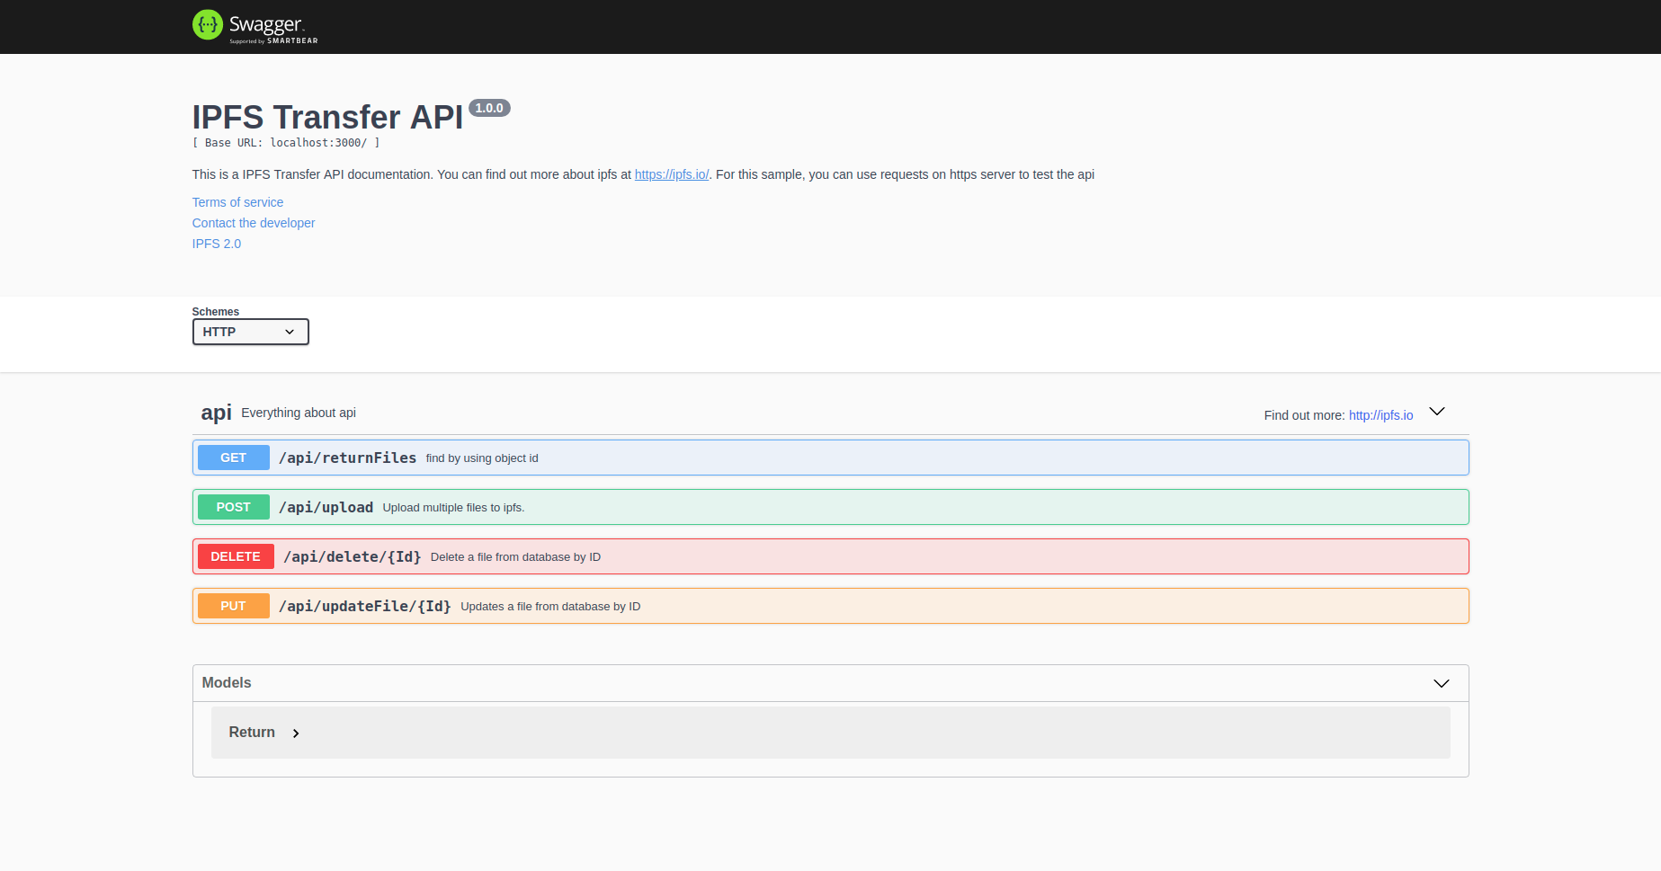

The above picture shows the 4 functionality that are inside the main API which are display(get), upload(post), delete(delete), update(put).

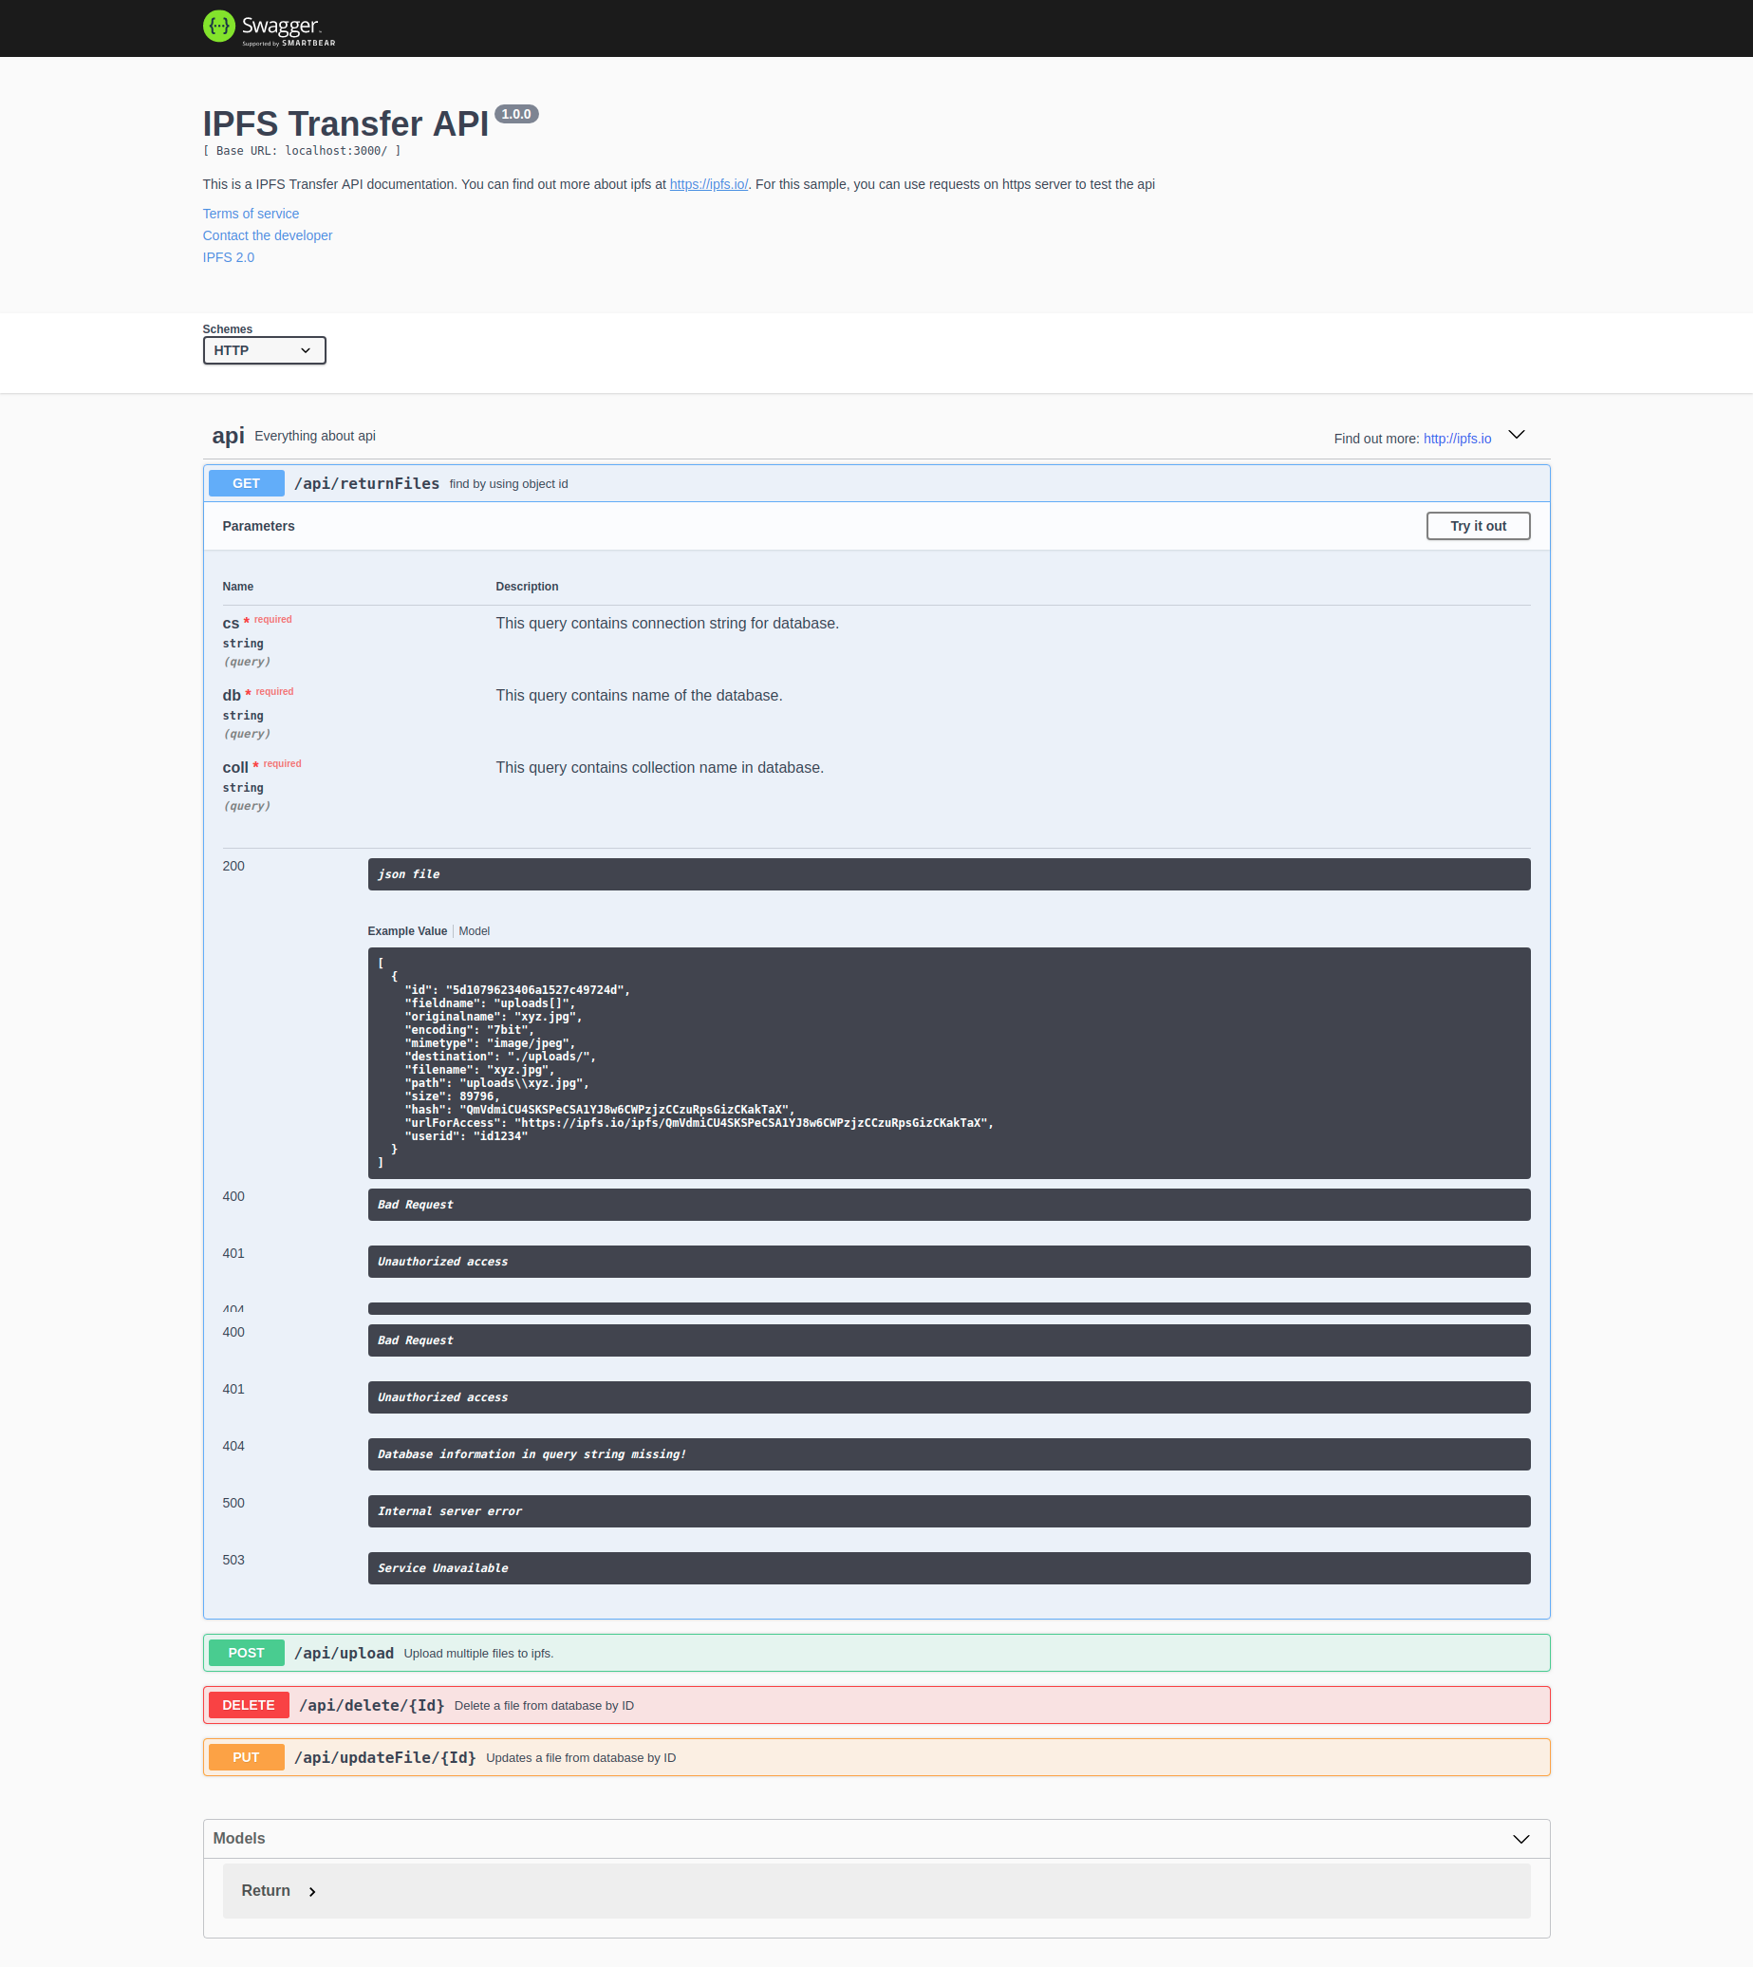

The first one is the functionality to display a file that is uploaded on the IPFS network. It is a get request.

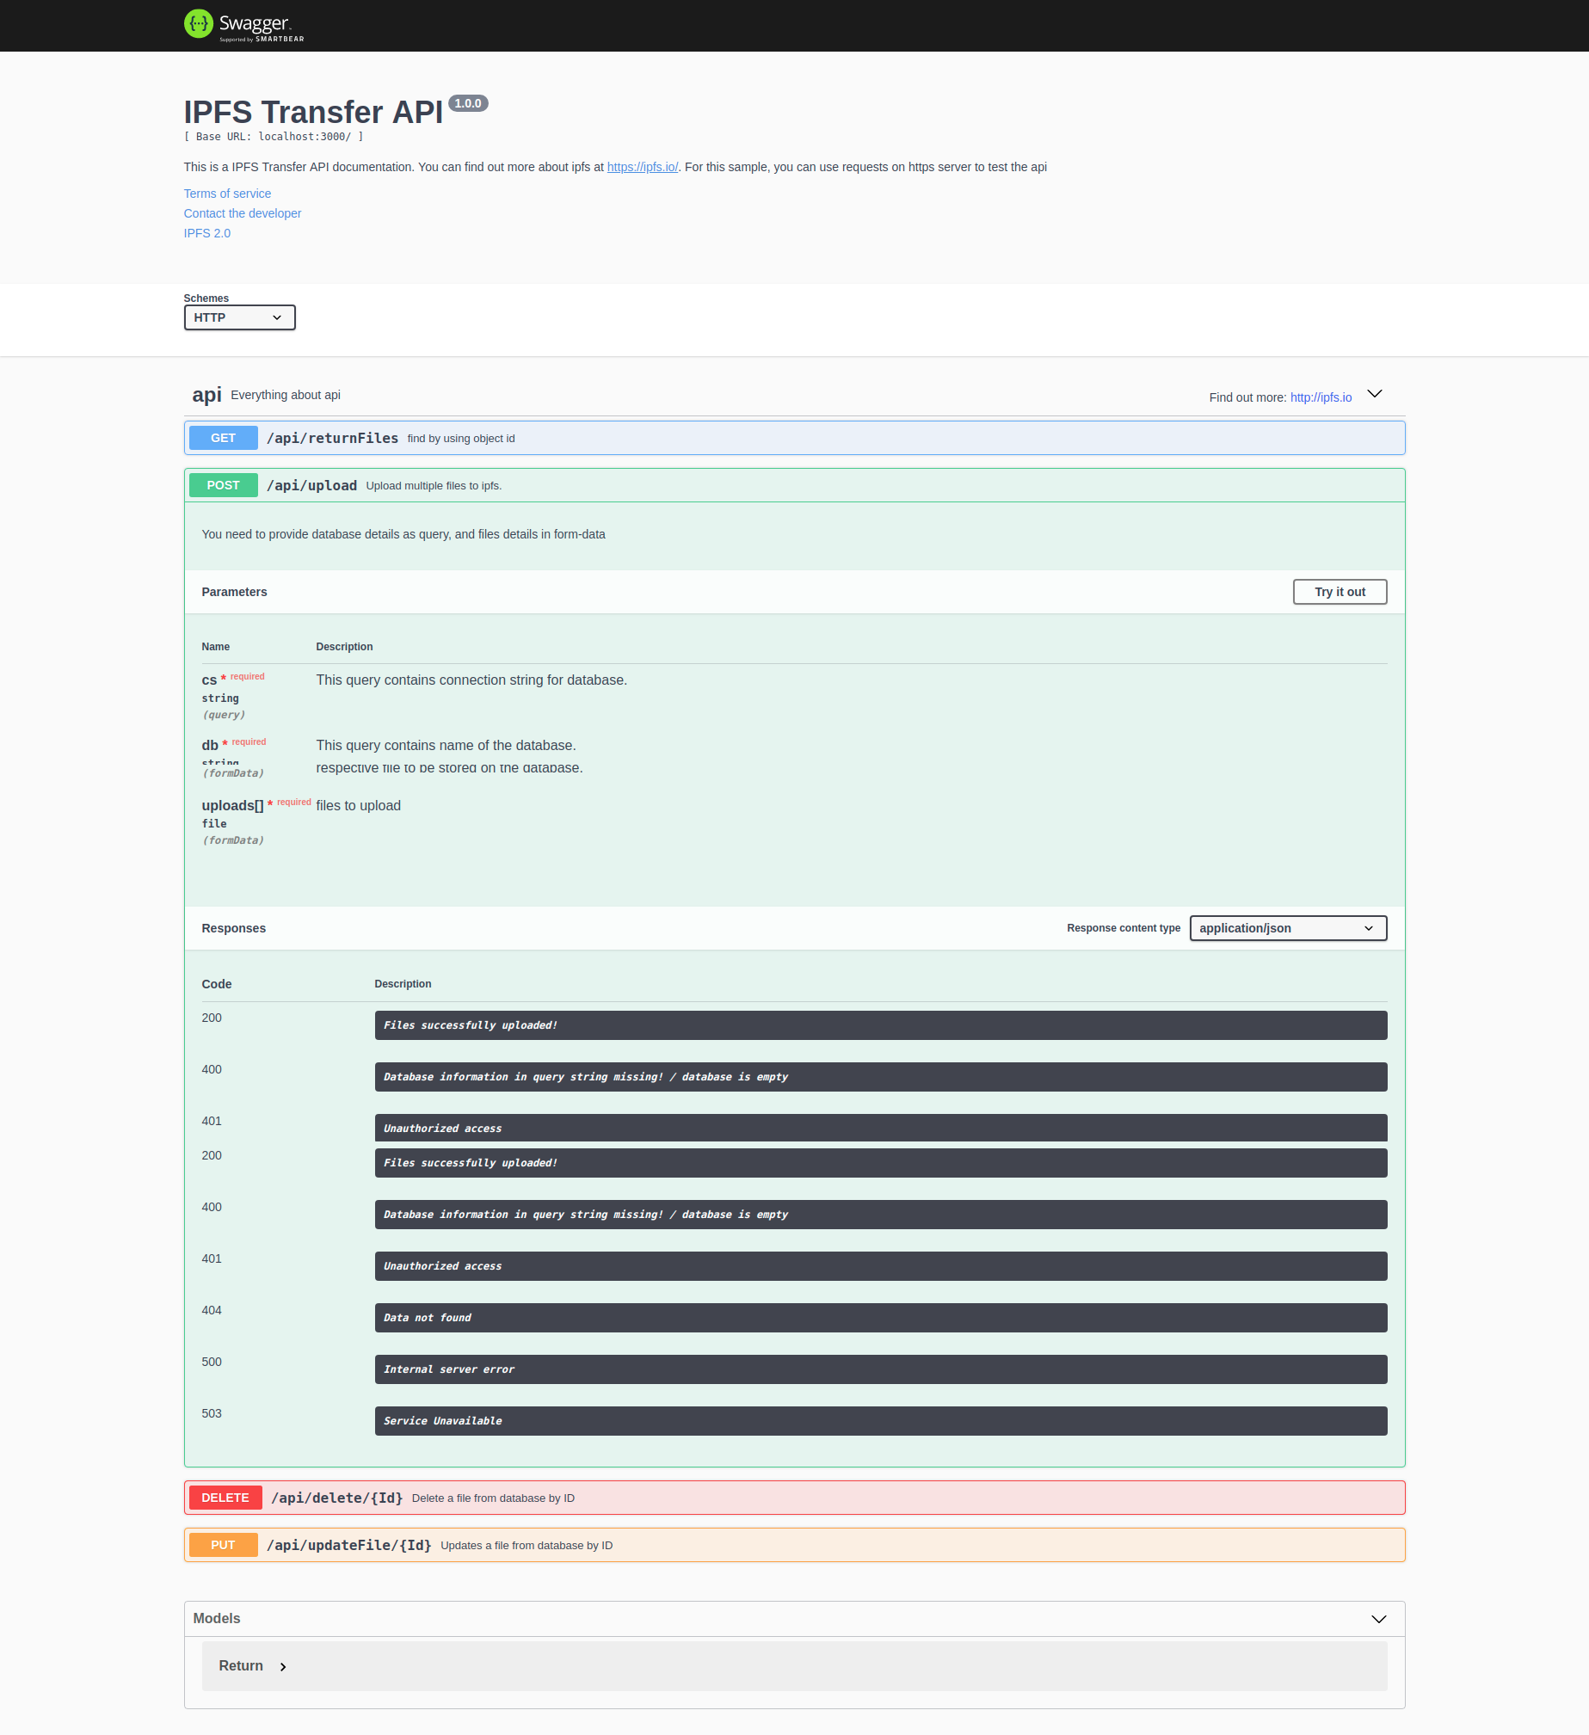

The second functionality is to upload a file and it is a post request. We can upload a file from the local system to the IPFS network through this post function.

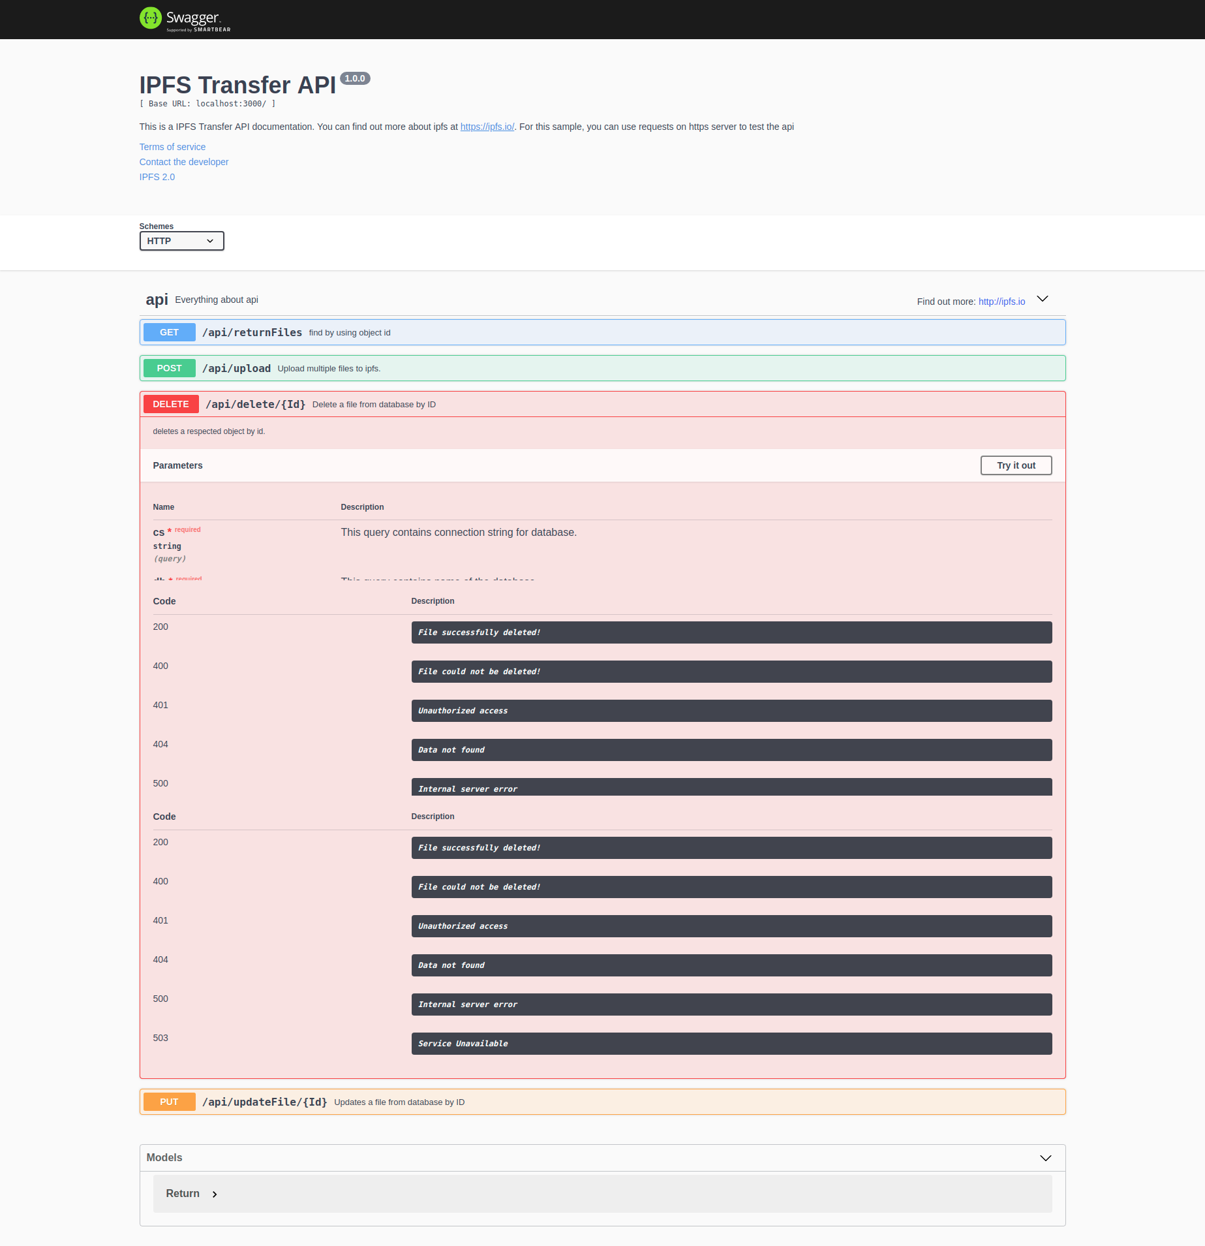

The third functionality is the delete functionality. This is a delete function and is used to delete the uploaded file from the Database.

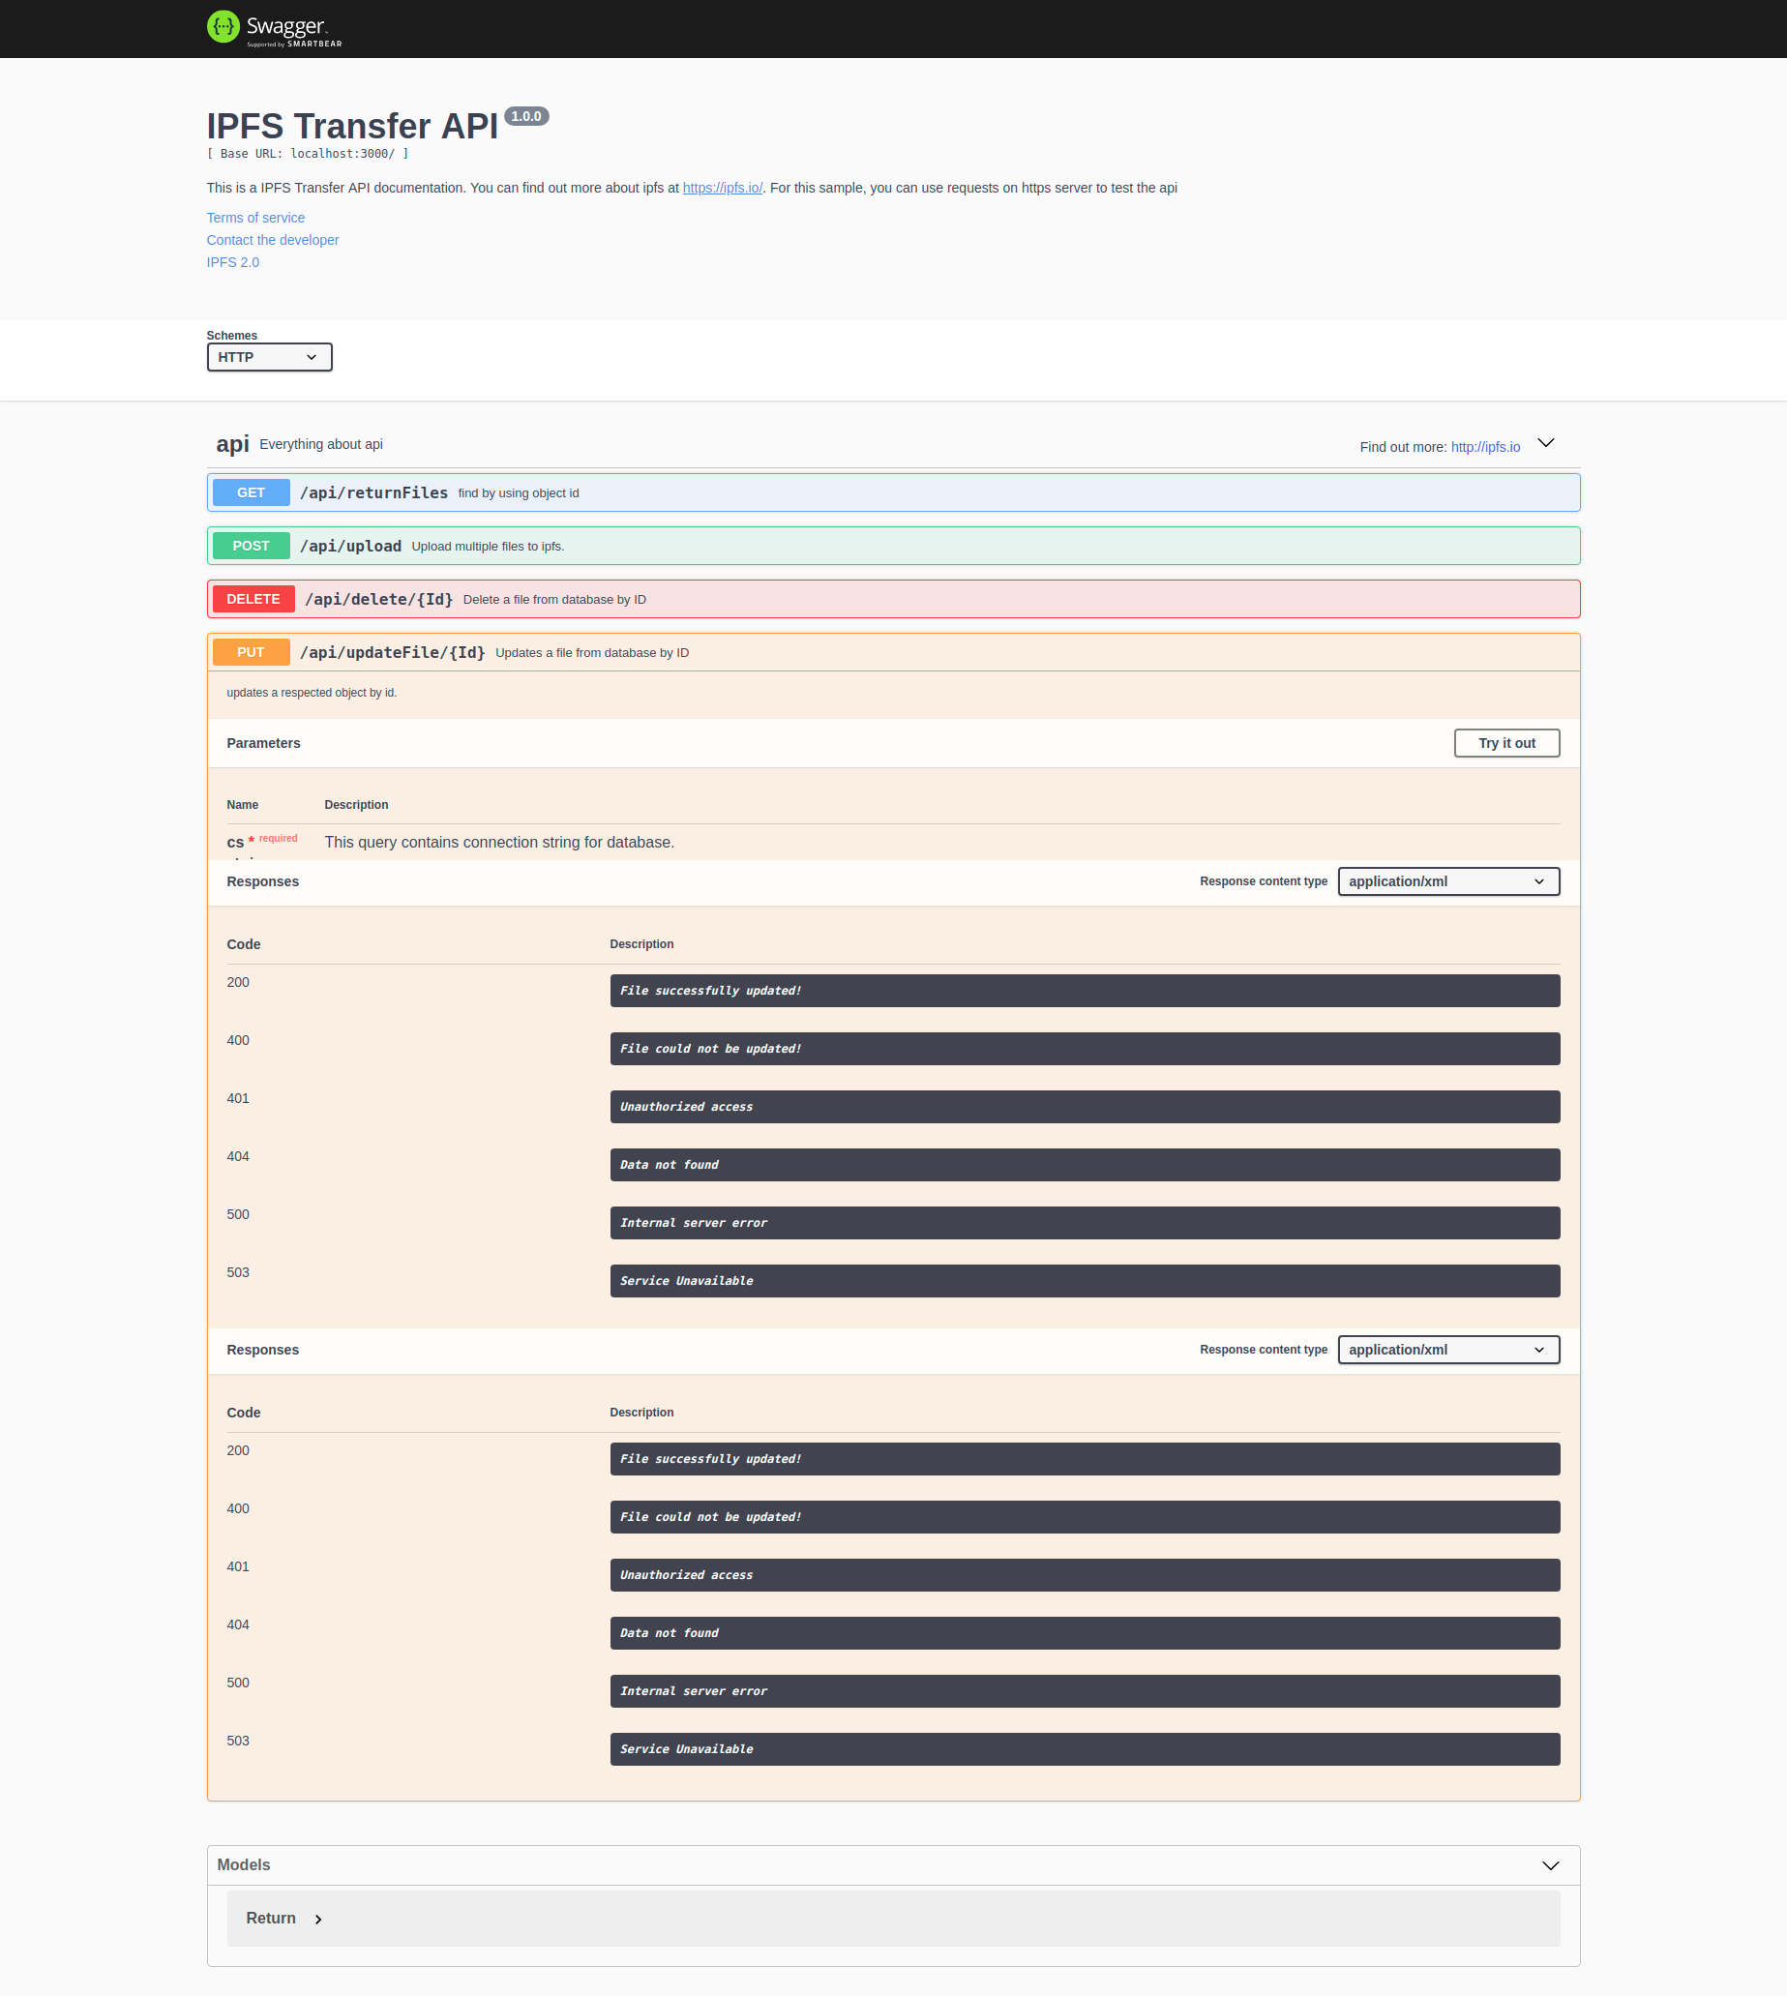

The fourth functionality is a put function which is update. Through this function, we can re-upload a file and delete the previously uploaded file from the IPFS network.

**Conclusion**

This API can be added into any software or website which requires IPFS functionality.

Using this API, we can use the main features of the IPFS and reduce the server load and distribute the data in the IPFS network for faster and non bulky operations.